**VacBIAS:. Oculomotor correlates of implicit attitudes towards COVID-19 vaccination.**

*Elena Artemenko1*, Aleksiia Syromyatnikova1, Sophia Popova1*

1Social & Cognitive Informatics Lab., HSE University, Saint Petersburg, 192148, Russia

**\*Corresponding author:**

Elena Artemenko, Social & Cognitive Informatics Lab., National Research University Higher School of Economics (HSE University), 55/2 Sedova, St., Petersburg, Russia, 192148. Telephone: +7 (812) 644-59-10 ext. 61312

Email: *nekrasovaed@gmail.com*

**Abstract**

The dataset comprises preprocessed data from a laboratory experiment (N participants = 30, N observations = 10,612), which includes recordings of eye movements during the completion of an Implicit Association Test (IAT) on attitudes toward COVID-19 vaccination. The preprocessed dataset contains 10,612 observations with 13 oculomotor metrics derived from 29,156 observations in the raw dataset, which includes gaze position coordinates and is also made available within this data report.

The dataset is unique in its inclusion of both implicit and explicit components of attitudes toward COVID-19 vaccination, alongside self-reported assessments of participants' expertise and health status, as well as vaccination experience. This combination renders the dataset exceptionally suitable for a wide range of exploratory studies in cognitive science, general psychology, and social psychology. Furthermore, it provides a foundation for designing and conducting confirmatory experiments, including those investigating cognitive mechanisms underlying implicit attitudes and cognitive biases. For machine learning practitioners, this dataset offers opportunities to address tasks such as behavioral data generation and feature extraction for classification problems, making it a valuable resource for interdisciplinary research.

**1. Introduction**

Implicit social cognition refers to the empirical phenomenon wherein prior experiences influence judgments and decisions. According to the theory of social attitudes, an individual's attitude toward an object is inherently linked to their behavior concerning that object (Eagly & Chaiken, 1993). This concept is exemplified in the global campaign for mass COVID-19 vaccination. The prevalence of anti-vaccine sentiments has led to a remarkably low willingness to get vaccinated. For instance, as per a survey conducted by VCIOM on December 23, 2020, only 38% of Russians intended to get the COVID-19 vaccine, while 52% expressed unwillingness (Vosheva et al., 2021). Similarly, a decline in vaccination willingness was documented in the U.S. (Fridman et al., 2021). Furthermore, a 2021 survey by the Johns Hopkins Center for Communication Programs, spanning 23 countries, reported a general decrease in vaccine acceptance (Johns Hopkins Bloomberg school and Public health survey, 2021).

Research on attitudes and the underlying cognitive mechanisms provides valuable insights into the cognitive nature of social attitudes and cognitive biases, such as confirmation bias (Nelson, 2014; Dasgupta & Ajzen, 2015). These biases significantly impact decision-making processes. Although research has refined our understanding of how attitudes predict behaviour (e.g., Godin et al., 2005), attitudes remain robust predictors, particularly concerning health-related behaviors (Spence & Townsend, 2006; McEachan et al., 2011).

Although attitudes’ predictive capacity is well-established, their measurement remains methodologically challenging. Researchers have noted that a combination of implicit and explicit assessments is necessary to improve predictive ability (Spence & Townsend, 2006) because explicit methods for assessing attitudes towards vaccination are influenced by social desirability and do not fully reveal the behavioural component of an individual's attitudes (Crowne & Marlowe, 1960; Paulhus, 1991, Shestopal, 2014; Wood & Schulman, 2021). Consequently, it is crucial to explore implicit attitudes, which are more stable and less influenced by conscious control (Greenwald & Banaji, 1995).

***Implicit Measures and Oculomotor Metrics***

The *Implicit Association Test (IAT)* is the most widely used method for assessing implicit attitudes due to its high predictive power (Greenwald et al., 1998; Greenwald et al., 2009). Recent studies affirm that the IAT effectively indicates implicit social attitudes across various socio-cultural phenomena (see Yatsenko et al., 2024, for a review).

*Oculomotor data* are promising indicators of implicit attitudes and biases (Mahaffey et al., 2005; Mahaffey et al., 2011; Amodio et al., 2003). For example, Mahaffey et al. (2005) found that increased blink amplitude correlated with negative attitudes toward gay individuals. Amodio et al. (2003) demonstrated that startle blink responses effectively reveal prejudiced reactions. Similarly, Marquart et al. (2016) noted that oculomotor metrics could be correlates of confirmation bias during online media perception. Thus, oculomotor data may approximate implicit attitudes and elucidate the cognitive mechanisms underlying their behavioral influence. Moreover, oculomotor metrics could significantly enhance discussions about the measurement validity of the IAT, addressing existing concerns in the research community. However, no open-access datasets currently link oculomotor data with IAT performance, as revealed by a literature review. This is the dataset we propose.

***The Proposed Dataset***

This data report introduces a novel dataset on participants' attitudes toward COVID-19 vaccination, combining a rare and unique mix of three types of attitude measurements.

* *Implicit attitudes*, assessed via a modified and validated IAT tailored for this dataset.
* *Explicit attitudes*, measured through validated scales.
* *Vaccination experience*, which enhances the explanatory power of predictive models (Hagger et al., 2002).

Additionally, the dataset includes preprocessed oculomotor data from the IAT, featuring 12 metrics derived from raw gaze positions. Both the preprocessed metrics and raw gaze data are provided for community use.

***Applications and Implications***

This dataset is invaluable for researchers in *health psychology*, offering insights into implicit and explicit attitudes toward vaccination and aiding in designing effective public health campaigns to enhance compliance. It also serves as a robust resource for exploratory studies in cognitive and social psychology, particularly in investigating implicit attitudes, social & cognitive biases, and oculomotor markers of these processes. The dataset can be employed to develop a wide range of predictive models, facilitating the testing of exploratory hypotheses and informing the design of subsequent experimental studies.

For machine learning applications, the dataset enables feature extraction for behavioral classification tasks and the generation of synthetic oculomotor datasets. An open-source Python library developed in our laboratory facilitates these analyses (documentation link omitted for anonymity).

This dataset contributes a foundational resource for interdisciplinary research, providing opportunities to explore and model the cognitive mechanisms that drive implicit social attitudes and their behavioral implications.

**2. Development and Validation of an Implicit Association Test for Vaccination Attitudes**

A review of the literature on the use of the Implicit Association Test (IAT) for vaccination-related topics revealed a lack of ready-to-use tools for assessing implicit attitudes toward vaccination. Only one study, conducted by Howell et al. (2022), investigated implicit vaccination attitudes using the IAT. However, this research focused on assessing parental attitudes toward childhood vaccination to explore the reasons behind vaccine hesitancy among parents. The methodological framework used in that study presented significant challenges for adaptation. Specifically, the authors selected "Vaccines" and "Vitals" (medical interventions in general) as target categories, which are inclusively related rather than antithetical.

Another study by Borgmann et al. (2024) assessed attitudes not toward vaccination per se but toward its potential side effects, further limiting the applicability of existing tools. This lack of an appropriate IAT methodology for vaccination topics prompted us to develop a novel tool, including a comprehensive validation cycle.

#### ***Stimulus Material Development and Validation***

The development and validation of the stimulus material occurred in three stages. In the first stage, potential stimuli for the test were selected based on an associative experiment (N = 100) and evaluated for valence and relevance to the target categories. Validation was conducted using three methods:

1. An online survey (N = 400; 200 male participants, representative sample).
2. A semantic distance analysis using word2vec in the R programming environment.
3. Qualitative expert evaluation (N = 5).

#### ***Pilot Testing***

To pilot the newly developed verbal IAT, a standalone web interface was created using Python for the server-side and HTML for the client-side implementation. The interface, accessible at<https://iat.linis-crowd.org/iat/9aa1320a-676a-4b56-9729-b2959e94d86c>, enabled participants to complete the IAT remotely. A total of 700 participants took part in the pilot study; however, data from 200 participants were excluded due to high error rates, resulting in a final sample size of N = 500 (230 male participants, mean age = 41.9, SD = 5).

#### ***Validation Results***

The internal consistency of the test was assessed using the split-half reliability method, which involved dividing the test into odd and even trials. The reliability coefficient was r = 0.542 (p < 0.001), indicating that the test is suitable for studying group differences and effects. The IAT demonstrated strong construct and criterion validity, along with internal consistency, supporting its use for evaluating the implicit component of attitudes toward vaccination.

This newly developed and validated IAT represents a significant contribution to the field, providing a robust and reliable tool for assessing implicit vaccination attitudes, which can be used in both academic and applied research contexts.

**3. Laboratory Experiment Design and Data Collection**

Following the validation process, the Implicit Association Test (IAT) was implemented using the EventIDE software platform to enable eye movement tracking during the experiment. Data were collected in a controlled laboratory setting between February 2024 and April 2024.

***3.1 Participants***

The study involved 30 participants (17 women; mean age = 26,23 *(5,97)*). Data from one participant were excluded due to elevated scores on the Beck Depression Inventory (BDI) that exceeded normative thresholds, while two others were excluded from the IAT block analysis due to poor eye tracker calibration. Participants were required to be at least 18 years old as of 2020, reflecting their potential exposure to mandatory COVID-19 vaccination campaigns and the presumption that they had already formed opinions about vaccination. All participants had normal or corrected-to-normal vision and no history of neurological or depressive disorders. Pre-screening employed three standardized questionnaires: the Beck Depression Inventory (BDI), the Pittsburgh Sleep Quality Index (PSQI), and the Fatigue Assessment Scale (FAS).

***3.2 Stimuli***

Stimuli were categorized into evaluative categories ("Good" and "Bad") and a target category ("Vaccination"). The character length of the stimuli was evaluated using Kruskal-Wallis ANOVA by Ranks and Wilcoxon matched-pair tests to ensure no significant differences (p > 0.7 for all comparisons) that could influence oculomotor responses.

#### **3.3 Equipment and Experimental Environment**

Participants were seated comfortably in a chair at a distance of 65–70 cm from a monitor displaying visual stimuli. Stimuli were presented as black text on a light gray background using a screen with a resolution of 2560 × 1440 pixels. The experimental setup included a workstation equipped with an Intel Core i7 processor running Windows 11 and an integrated eye tracker mounted beneath the monitor. Artificial lighting was used to minimize interference from natural light. A schematic representation of the laboratory setup is shown in Figure 1.

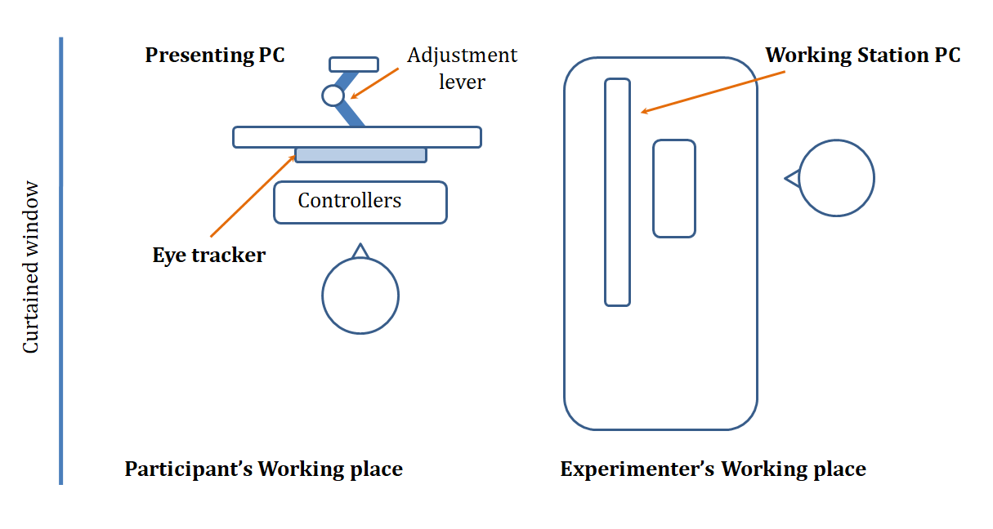

***Figure 1:*** *Schematic representation of the laboratory setup.*

#### **3.4 Research Protocol and Study Design**

The research protocols were reviewed and approved by the Ethics Committee of HSE University Saint Petersburg. Participants were blind to the study's hypotheses and objectives and provided written informed consent before participation.

***Calibration***

Participants underwent a standard five-point calibration procedure before the experimental session, with an accuracy threshold of <0.5 degrees (44 pixels) required for inclusion. Calibration accuracy was monitored in real time, and recalibration was performed as necessary during the experiment.

***Steps***

The experiment consisted of three blocks:

1. **Sociodemographic Information:** Participants provided demographic information, including gender, age, educational background, and educational attainment.
2. **Explicit Attitudes Toward Vaccination:** Participants completed three validated questionnaires to assess explicit vaccination attitudes: the Vaccination Attitudes Examination (VAX) Scale, the COVID-19 Vaccination Attitudes Scale, and the Vaccine Conspiracy Beliefs Scale. These instruments have demonstrated robust factorial structures, high internal consistency, and construct validity.
3. **Implicit Attitudes Toward Vaccination:** Participants completed a single-category IAT designed to assess implicit attitudes toward vaccination while eye movements were recorded.

***Experimental trial***

The experimental trial involved displaying a fixation cross that participants were required to focus on for 800 ms, triggering the presentation of a stimulus screen. Participants categorized each stimulus by pressing either the "E" or "I" key, labeled with stickers for clarity. Correct responses advanced to the next trial, while incorrect responses displayed an "X" and the message "Press the correct answer." Correcting the response triggered the next trial. Oculomotor data were recorded exclusively during the stimulus presentation phase. A schematic representation of the experimental trial is presented in Figure 2.

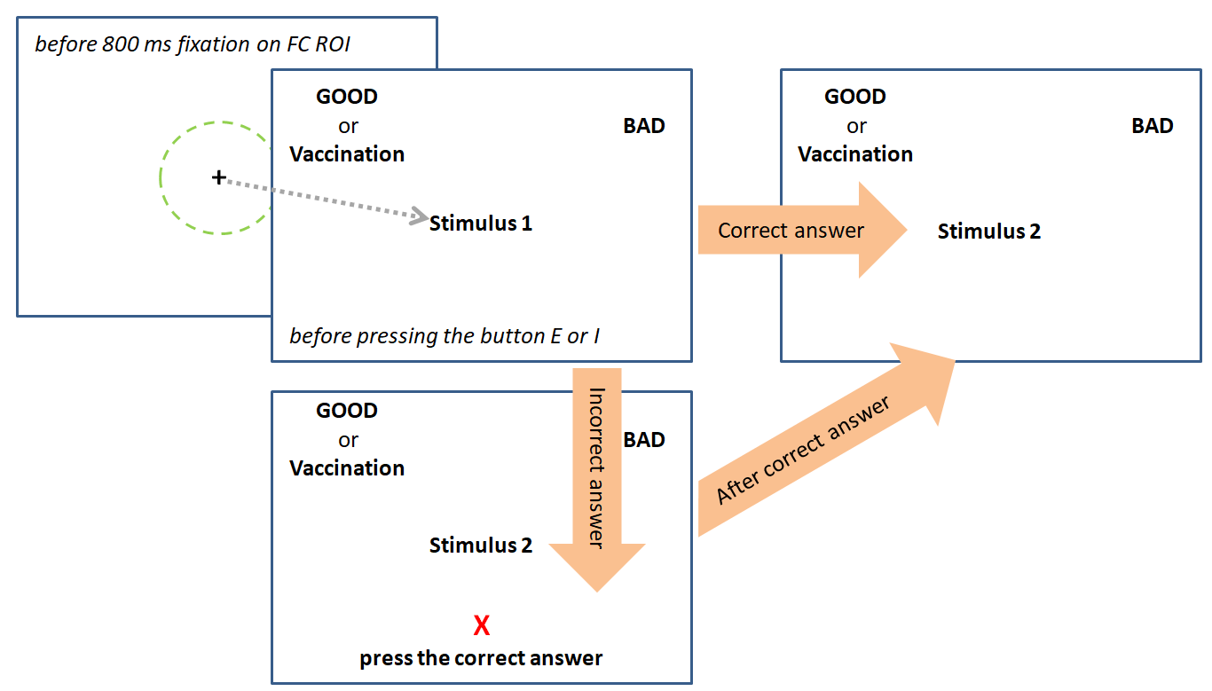

***Figure 2:*** *Diagram of an experimental trial.*

This experimental design ensured precise data collection and control over potential confounding variables, supporting the reliability and validity of the results.

**4 *Data preprocessing***

For all the scale variables used in the study, composite indices were calculated to reflect participants’ overall attitudes toward vaccination. These indices provide a comprehensive measure of explicit attitudes, enabling a systematic analysis of individual responses. Regarding the results of the Implicit Association Test (IAT), the **D measure** was calculated as a standard metric to evaluate the strength and direction of associative links. Additionally, a **consistency** metric was attributed to assess the internal reliability of the IAT results, which can be recalibrated or redefined in relation to the implicit measures, if desired. Also note that for the preprocessed dataset, the coding for employed media, employed medicine, vaccination experience, conspiracy religion and conspiracy politics have been reversed (0 - No, 1 - Yes) for convenience. The indexes for the variables explicit_general, explicit COVID and explicit cospiracy have also been reversed for a more intuitive understanding of the results. All changes are noted in Table 1.

### ***Oculomotor Data***

From the raw datasets of oculomotor data, presented as individual files for each participant, 13 oculomotor metrics were derived and included in the aggregated dataset. These metrics focus on key features related to fixations and saccades, and they are outlined below. For transparency and further exploration, the raw data files are also available, containing gaze position coordinates (X and Y axes) recorded during each trial of the IAT.

**5 *Measures***

The overall map of all variables and measurements contained in the dataset is presented in Appendix 1. A schematic representation of the measurements is shown in Figure 3.

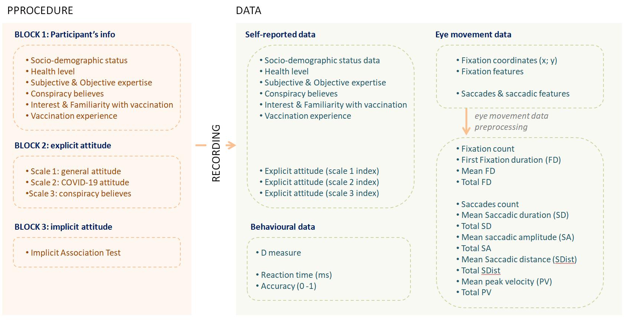

***Figure 3****: A schematic representation of the measurements for raw and preprocessed datasets*

5.1. **Participant Information**The "*Participant*" variable contains a unique participant ID.  
The "*Experiment_Step*" variable indicates the training session ("train") and experimental session ("experiment").

5.2. **Sociodemographic Data**The experimental design included a standard set of questions that characterize the sample based on key sociodemographic variables, including *age* (numeric), *gender* (1 - male, 2 - female), *level of education*, and *field of study.*

5.3. **Health Status**We included a self-reported health status question in the experiment, using a Likert scale where 1 represents very poor health and 8 represents very good health.

**5.4. Expertise level**

We asked participants whether their occupation is related to the medical field (*employed_medicine)*, using this information as a control factor. This is because individuals with education and/or experience in medicine may influence the general results regarding the credibility of vaccination-related messages.

We also assessed the participants' *familiarity* and *interest* in the topics of medicine and vaccination. Participants were asked to rate their familiarity with these topics on an 8-point Likert scale, where 1 means "not familiar at all" and 8 means "very familiar." Interest in the topic (interest) was also rated on an 8-point Likert scale, where 1 means "not interested at all" and 8 means "very interested." We expect that these two parameters could be used to calculate a weighted subjective expertise score in the domain of vaccination.

*Vaccination_experience.* This metric reflects participants' willingness to get vaccinated if recommended by a doctor, including COVID-19 vaccination. Participants were asked: "Do you get vaccinated when recommended by a doctor?" with responses coded as 0 for "no" and 1 for "yes."

5.5. **Conspiracy Level**We also assessed the participants' tendency to believe in conspiracy theories. Specifically, we inquired whether they consider themselves religious (conspiracy_religion: 0 - no, 1 - yes) and whether they believe that everything in the world happens for a reason (conspiracy_politics: 0 - no, 1 - yes).

5.6. **Stimulus Information**Stimulus information included the block number of the IAT procedure, its categorical classification (positive, negative, or vaccination), the index of each stimulus, and the valence of the block. The **Block_Valence** variable reflected the context in which the target and evaluative categories were combined: positive - vaccination combined with a positive evaluation, negative - vaccination combined with a negative evaluation.

5.7. **Implicit Attitude***IAT_results* were calculated based on the methodology described by Greenwald et al. (2003), which aims to identify an index variable based on the difference in reaction times between congruent and incongruent blocks. This metric contains the result of the respondents' answers (D measure), which is measured on a scale from -1 < result < 1. A value less than 0 reflects a negative implicit attitude, while values greater than 0 reflect a positive implicit attitude. Additionally, the larger the value of the D measure in absolute terms, the stronger the attitude.

*IAT_strength* reflects the quantile distribution of attitude strength: 0 - most negative, 1 - negative, 2 - neutral, 3 - positive, 4 - most positive.

5.8. **Consistency: Implicit**

The consistency of the statement's valence with the participant's attitude (consistency) was assessed as the interaction between the attitude toward the topic (attitude) and the valence of the statement. Based on the test results, each block was assigned a value of **match** or **mismatch**, reflecting whether the valence of the block aligned with the respondent's result. If a respondent demonstrated a negative implicit attitude toward vaccination, blocks combining the categories “Vaccination” and “Good” were considered incongruent for that respondent, while blocks combining the categories “Vaccination” and “Bad” were considered congruent.

5.9. **Explicit Attitude Toward Vaccination**The explicit attitude toward vaccination was assessed using the following scales: (1) the COVID-19 Vaccination Attitudes Scale (Margolis et al., 2022), (2) the Russian version of the Vaccine Conspiracy Beliefs Scale (Uglanova et al., 2021), and (3) the Vaccination Attitudes Examination (VAX) Scale (Martin & Petrie, 2017). All scales demonstrate high internal consistency and test-retest reliability, with confirmed factor structures and both construct and criterion validity. These tools were selected for evaluating attitudes toward COVID-19 vaccination and the extent of conspiracy beliefs regarding vaccination.

***Explicit Attitude: General Attitude***The Vaccination Attitudes Examination (VAX) Scale by L.R. Martin & K.J. Petrie measures attitudes toward vaccination and its perceived benefits on a continuum of “necessity-worry” through 12 statements, with responses marked on a 6-point Likert scale. A notable strength of the scale is the presence of four subscales that measure different aspects of attitudes toward vaccination: distrust in the main effect of vaccination, concern about unknown long-term effects, worries about the dominance of commercial interests, and preference for natural immunity. The total score on the scale reflects general views on vaccination and its benefits, following the “necessity-worry” continuum. This continuum is often used by healthcare providers when addressing the beliefs underlying patients' decisions regarding medical treatment (West et al., 2018).

The Russian version of the VAX Scale, adapted by (Authors names deleted from the blinded version), demonstrated confirmed factor structure: χ2(48) = 161 (p < 0.001), CFI = 0.958, TLI = 0.942, RMSEA = 0.0768, SRMR = 0.0492; high internal consistency (α ≥ 0.9), and construct and criterion validity (Reference deleted from blind manuscript). The original English version showed strong internal consistency (α ≥ 0.86), test-retest reliability (r = 0.84; p < 0.001), and confirmed construct and criterion validity (Martin & Petrie, 2017).

***Explicit Attitude: Conspiracy Beliefs***The Vaccine Conspiracy Beliefs Scale, by J.K. Shapiro et al. (Validation of the Vaccine Conspiracy Beliefs Scale), is unidimensional and measures the strength of conspiracy beliefs about vaccination. It consists of 7 statements, with responses marked on a 7-point Likert scale.

For the Russian version, adapted by I.L. Uglanova and colleagues, empirical data were aligned with the hypothesized model using Rasch modeling, and high internal consistency was confirmed (α = 0.86) (Uglanova et al., 2021). The original English version also demonstrated high internal consistency and construct validity (Shapiro et al., 2016).

***Explicit Attitude: COVID-19 Attitude***The COVID-19 Vaccination Attitudes Scale (Margolis et al., 2022) assesses attitudes toward COVID-19 vaccination through 34 statements, with responses indicated on a 7-point Likert scale. These statements form five subscales: the benefits of COVID-19 vaccination for individuals and society, fear of side effects from the COVID-19 vaccine and distrust of information about its safety, denial of the dangers posed by the coronavirus, hope for natural immunity, and disbelief in the proven effectiveness of Russian vaccines internationally.

The COVID-19 Vaccination Attitudes Scale has a confirmed factor structure through confirmatory factor analysis, good internal consistency (α ≥ 0.71), and construct validity (Margolis et al., 2022).

5.10 **Measures: Behavioral Data  
Reaction Time** reflects the time in milliseconds from the appearance of the stimulus on the screen until the participant presses a key on the keyboard. It is important to note that for incorrect responses (accuracy = 0), the reaction time is recorded until the correct key is pressed. Therefore, when analyzing reaction times, incorrect responses should be excluded.

**Accuracy** indicates the correctness of the categorization made (0 - incorrect, 1 - correct).

5.11 **Measures: Eye Movements Data**The dataset includes 13 eye movement metrics for each experimental trial:

* **Fixation Count**: The total number of fixations on a given stimulus or target.
* **First Fixation Duration (First_FD)**: The duration of the first fixation on a given stimulus or target.
* **Mean Fixation Duration (Mean_FD)**: The average duration on a given stimulus or target.
* **Total Fixation Duration (Total_FD)**: The total duration on a given stimulus or target.
* **Saccades Count (Saccades_Count)**: The total number of saccadic eye movements on a given stimulus or target.
* **Mean Saccadic Duration (Mean_SD)**: The average duration of saccades on a given stimulus or target.
* **Total Saccadic Duration (Total_SD)**: The cumulative duration on a given stimulus or target.
* **Mean Saccadic Amplitude (Mean_SA)**: The average angular displacement of gaze shifts between fixations on a given stimulus or target.
* **Total Saccadic Amplitude (Total_SA)**: The total angular displacement accumulated by all saccades on a given stimulus or target.
* **Mean Saccadic Distance (Mean_SDist)**: The average distance traveled by the eyes during each saccadic movement on a given stimulus or target.
* **Total Saccadic Distance (Total_SDist)**: The total distance traveled by the eyes across all saccades during the task on a given stimulus or target.
* **Mean Pupil Velocity (Mean_PV)**: The average speed of the pupil's movement during fixations and saccades.
* **Total Pupil Velocity (Total_PV)**: The total velocity of the pupil's movement across the entire experiment.

This set of metrics provides detailed information about the duration and intensity of fixations and saccades during the experimental trials, contributing to a comprehensive understanding of participants' eye movement patterns.

***Table 1.*** *A summarising table describing all the main variables and measures presented in the preprocessed dataset.*

| **MEASURES** | **DESCRIPTION** |
| --- | --- |
| **Participants information** | |
| Participant | The unique ID for each participant: *EEGCB12002... EEGCB110030.* |
| **Socio-demographic data** | |
| Age | *int.* |
| Gender | Your gender:  0 - Male  1 - Female  2 - Prefer not to answer |
| Education_level | Your education level:  0 - Secondary vocational (college, technical school)  1 - Incomplete higher education (did not finish university)  2 - Higher education (bachelor's degree)  3 - Master's degree  4 - Multiple higher degrees  5 - I have a PhD |
| Education_bac | 0 - Natural sciences  1 - Medical  2 - Social sciences and humanities  3 - Physical and mathematical  4 - Mathematics-informatics (including IT)  5 - Creative disciplines |
| Education_master |
| Education_phd |
| **Health status** | |
| Health_level | Please assess your health level  Likert scale: 1 (very poor) - 5 (very good) |
| **Expertise** | |
| Employed_media | Is your field of activity related to media or journalism?  0 - No, 1 - Yes.  (*vice versa for raw datasets*) |
| Employed_medicine | Is your field of activity related to medicine?  0 - No, 1 - Yes.  (*vice versa for raw datasets*) |
| Familiriarity_medicine | How familiar are you with the topic of medicine?  Likert scale 1 (completely not familiar) - 8 (completely familiar). |
| Familiriarity_vaccination | How familiar are you with the topic of vaccination?  Likert scale 1 (completely not familiar) - 8 (completely familiar). |
| Interest_medicine | How interested are you in the topic of medicine?  Likert scale 1 (completely not interesting) - 8 (very interesting). |
| Interest_vaccination | How interested are you in the topic of vaccination?  Likert scale 1 (completely not interesting) - 8 (very interesting). |
| Vaccination_experience | Would you get vaccinated if doctors recommended it?  0 - No, 1 - Yes.  (*vice versa for raw datasets*) |
| **Conspiracy** | |
| Conspiracy_religion | Can you consider yourself a religious person?  0 - No, 1 - Yes.  (*vice versa for raw datasets*) |
| Conspiracy_politics | Do you think that everything in the world happens for a reason?  0 - No, 1 - Yes.  (*vice versa for raw datasets*) |
| **Stimulus information** | |
| Experiment_Step | Parts of the experiment: *train* for each training part before each block and *main* for experimental parts. |
| Block_Number | Digital identification of the experiment blocks |
| Target_Valence | Category of the target word: : *positive / negative / vaccination.* |
| Index | Index of each unique stimulus (1-24). |
| Block_Valence | Valence of the blocks in the experiment: *positive vs negative.* |
| **Measures** | |
| **Implicit attitude** |  |
| IAT_result | (negative) -1 < x < 1 (positive) |
| IAT_streght | (strong negative) -2, -1, 0, 1, 2 (strong positive) |
|  |  |
| **Consistency** | *mismatch* (for congruent conditions) vs *match* (for incongruent conditions) |
|  |  |
| **Explicit attitude** |  |
| Explicite_general | (negative) 1 < x < 6 (positive)  (*vice versa for raw datasets*) |
| Explicite_conspiracy | (negative: believe in conspiracy theories about vaccination ) 1 < x < 7 (positive: believe in conspiracy theories about vaccination)  (*vice versa for raw datasets*) |
| Explicite_covid | (negative) 1 < x < 7 (positive)  (*vice versa for raw datasets*) |
|  |  |
| **Measures: behavior data** |  |
| Reaction_Time | *int.* |
| Accuracy | *0* - for wrong answer, *1* - for right answer |
| **Measures: eye movements data** | |
| Fixation_Count | *int.* |
| First_FD | *int.* |
| Mean_FD | *int.* |
| Total_FD | *int.* |
| Saccades_Count | *int.* |
| Mean_SD | *int.* |
| Total_SD | *int.* |
| Mean_SA | *int.* |
| Total_SA | *int.* |
| Mean_SDist | *int.* |
| Total_SDist | *int.* |
| Mean_PV | *int.* |
| Total_PV | *int.* |

**6. Some statistics**

To illustrate the results, we present some statistics based on the dataset material.

First, Table 2 shows the means and standard deviations of the key self-reported ratings, as well as the explicit and implicit components of attitudes.

***Table 2.*** *Descriptive statistics for the key self-reported ratings, as well as the explicit and implicit components of attitudes*

| **VARIABLE** | **MEAN** | **SD** |
| --- | --- | --- |
| **General information** | | |
| Conspiracy religion (0-1) | 0.228 | 0.420 |
| Conspiracy politics (0-1) | 0.480 | 0.490 |
| Vaccination experience (0-1) | 0.770 | 0.421 |
| Health level (1-7) | 3.698 | 0.534 |
| Vaccination interest (0-7) | 3.260 | 1.193 |
| Medicine Interest (0-7) | 4.490 | 1.424 |
| Vaccination Familiarity (0-7) | 3.547 | 1.654 |
| Medicine Familiarity (0-7) | 3.062 | 1.267 |
| Employed medicine (0-1) | 0.056 | 0.229 |
| **Attitudes** | | |
| IAT result (-1 < x < 1) | 0.048 | 0.343 |
| IAT strength (-2 < x < 2) | -0.115 | 1.437 |
| Explicit general scale (1-6) | 2.543 | 1.103 |
| Explicit covid scale | 2.872 | 1.049 |
| Explicit conspiracy scale | 1.99 | 1.261 |

As shown in Figure 1, the distribution of IAT scores is bimodal, with the highest frequencies observed for the scores -0.25 and 0.2. This allows us to identify two distinct groups among participants: "vaxxers" and "anti-vaxxers," respectively. Furthermore, the participants can be grouped based on the strength of their attitude using the quartiles of the IAT strength measure (IAT_strength).

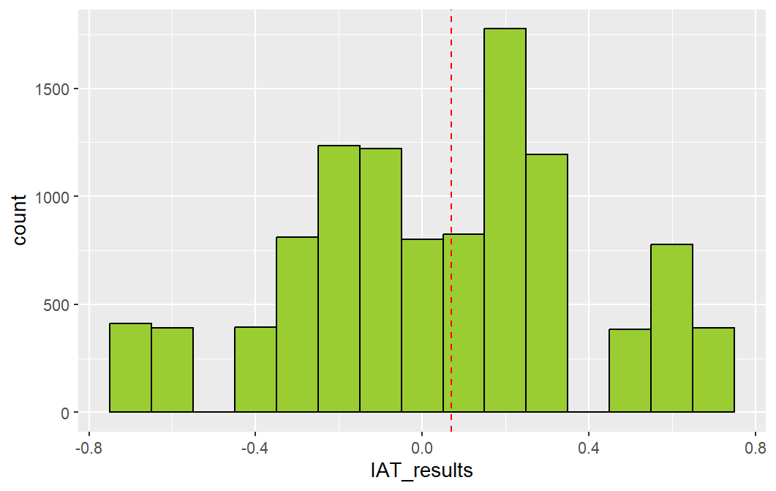

***Figure 4.*** *Distribution of implicit attitude scores obtained during the Implicit Association Test.*

As shown in Figure 5, the explicit component of the attitude reveals a generally positive stance towards COVID-19 vaccination, an absence of conspiracy beliefs about vaccination, and a predominantly neutral or moderate overall attitude towards vaccination.

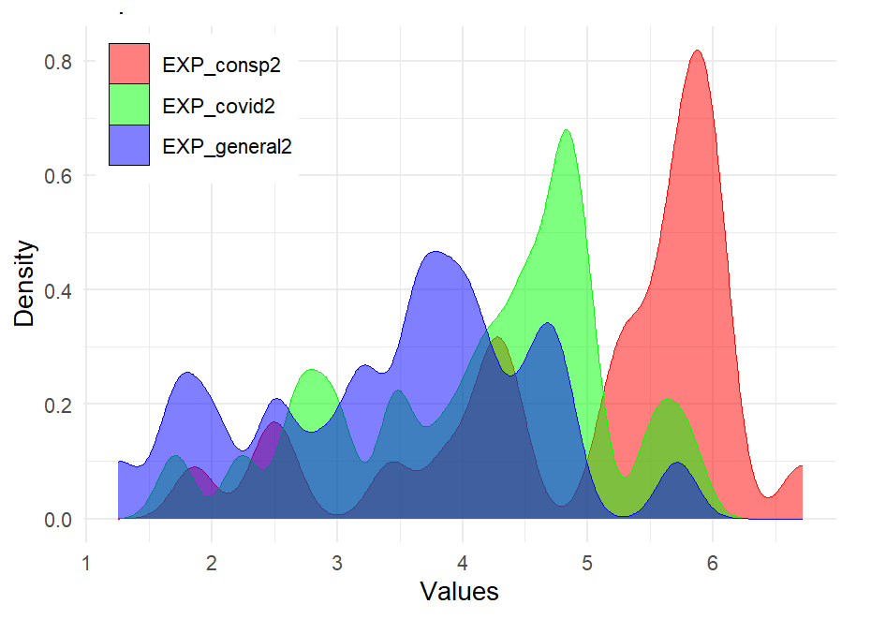

***Figure 5.*** *Distribution of explicit attitude scores obtained from the COVID-19 Vaccination Attitudes Scale (Margolis et al., 2022), the Vaccine Conspiracy Beliefs Scale (Uglanova et al., 2021), and the Vaccination Attitudes Examination (VAX) Scale (Deleted from the blinded version).*

We also examined the correlation between the results of the explicit and implicit components. The correlation analysis showed a moderate correlation between the implicit and explicit components of the attitude (see Figure 6).

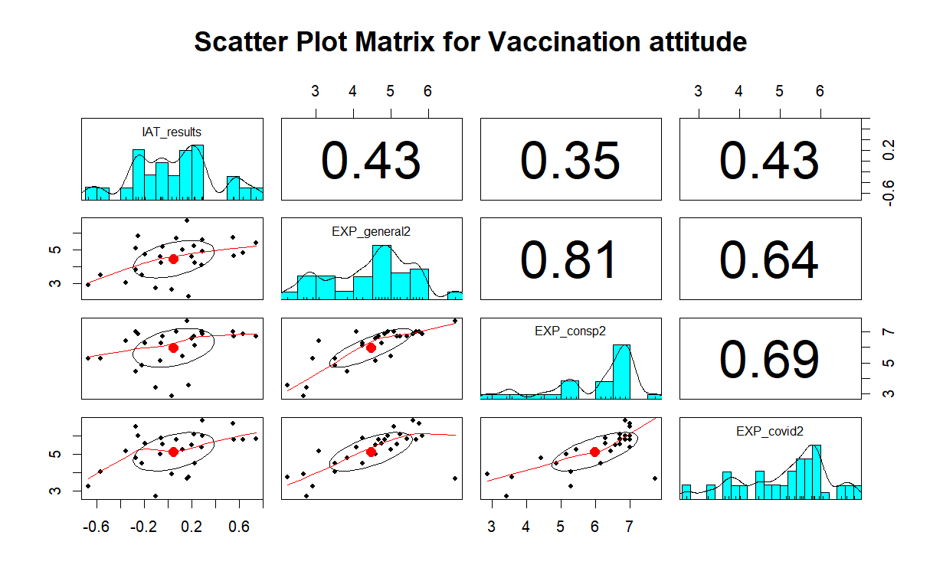

***Figure 6.*** *Correlation matrix between the implicit and explicit components of attitude.*

Table 3 provides descriptive statistics for eye movement data related to the *consistency* variable, indexed based on the implicit component of attitude.

***Table 3.***  *Descriptive statistics for eye movement data related to the consistency variable, indexed based on the implicit component of attitude.*

| **CONSISTENCY CONDITION** | **First FD** | **Total FD** | **Total SD** | **Total SA** | **Total SDist** |
| --- | --- | --- | --- | --- | --- |
| congruent | 252 (212) | 468 (328) | 102 (183) | 1.8 (6.3) | 2.4 (7.6) |
| incongruent | 257 (223) | 518 (388) | 130 (223) | 2.7 (11.1) | 3.7 (15.4) |

It can be observed that the variation in behavioral data is quite high among participants, which is confirmed by the ICC test (> 0.05 for participants but < 0.05 for items). This necessitates accounting for the random effect of the participant when considering linear models.

**References**

1. Eagly, A. H., & Chaiken, S. (1993). The psychology of attitudes. Harcourt Brace Jovanovich.
2. Fridman, A., Gershon, R., & Gneezy, A. (2021). COVID-19 and vaccine hesitancy: A longitudinal study. PloS one, 16(4), e0250123. <https://doi.org/10.1371/journal.pone.0250123>
3. Johns Hopkins, 2021. COVID-19 Vaccine Acceptance Falling Globally and in the U.S., Survey Finds, Link: <https://publichealth.jhu.edu/2021/covid-19-vaccine-acceptance-falling-globally-and-in-the-us-survey-finds>
4. Nelson, J. A. (2014). The power of stereotyping and confirmation bias to overwhelm accurate assessment: the case of economics, gender, and risk aversion. Journal of Economic Methodology, 21(3), 211–231. <https://doi.org/10.1080/1350178X.2014.939691>
5. Dasgupta, N. & Ajzen, I. (2015). Explicit and Implicit Beliefs, Attitudes, and Intentions: The Role of Conscious and Unconscious Processes in Human Behavior. doi: 10.1093/acprof:oso/9780190267278.003.0005.
6. Crowne DP, Marlowe D (1960) A new scale of social desirability independent of psychopathology. J Consult Psychol 24: 349–354
7. Paulhus DL (1991) Measurement and control of response bias. In: Robinson JP, Shaver PR, Wrightsman LS, editors. Measures of personality and social psychological attitudes. San Diego, CA: Academic Press. pp.17–59.
8. Wood, S., & Schulman, K. (2021). When Vaccine Apathy, Not Hesitancy, Drives Vaccine Disinterest. JAMA, 325(24), 2435–2436. <https://doi.org/10.1001/jama.2021.7707>
9. Shestopal, Ye. B. (2014). Sociological surveys and electoral forecasts – methodic aspects. Sotsiologicheskie Issledovaniya [Sociological Studies], 5, 136–138.
10. Crowne DP, Marlowe D (1960) A new scale of social desirability independent of psychopathology. J Consult Psychol 24: 349–354
11. Paulhus DL (1991) Measurement and control of response bias. In: Robinson JP, Shaver PR, Wrightsman LS, editors. Measures of personality and social psychological attitudes. San Diego, CA: Academic Press. pp.17–59.
12. Wood, S., & Schulman, K. (2021). When Vaccine Apathy, Not Hesitancy, Drives Vaccine Disinterest. JAMA, 325(24), 2435–2436. <https://doi.org/10.1001/jama.2021.7707>
13. Greenwald AG, McGhee DE, Schwartz JLK (1998) Measuring Individual Differences in Implicit Cognition: The Implicit Association Test. J Pers Soc Psychol 74: 1464–1480
14. Greenwald, A. G., Poehlman, T. A., Uhlmann, E. L., & Banaji, M. R. (2009). Understanding and using the Implicit Association Test: III. Meta-analysis of predictive validity. Journal of personality and social psychology, 97(1), 17–41. <https://doi.org/10.1037/a0015575>
15. Martin, L. R., & Petrie, K. J. (2017). Understanding the Dimensions of Anti-Vaccination Attitudes: the Vaccination Attitudes Examination (VAX) Scale. Annals of behavioral medicine : a publication of the Society of Behavioral Medicine, 51(5), 652–660. <https://doi.org/10.1007/s12160-017-9888-y>
16. Uglanova, I. L., Mikhaylova, A. M., Belskaya, T. V., & Getman, A. V. (2021). Conspiracy beliefs about vaccination: Questionnaire validation. Vestnik of Saint Petersburg University. Sociology, 14(1), 14–32. https://doi.org/10.21638/spbu12.2021.102
17. Shapiro, G. K., Holding, A., Perez, S., Amsel, R., & Rosberger, Z. (2016). Validation of the vaccine conspiracy beliefs scale. Papillomavirus research (Amsterdam, Netherlands), 2, 167–172. <https://doi.org/10.1016/j.pvr.2016.09.001>
18. Margolis, A. A., Sorokova, M. G., Shvedovskaya, A. A., & Radchikova, N. P. (2022). The Questionnaire “COVID-19 Vaccine Attitude Scale” (COVID-19 VAS): Development and Standardization. Psychology. Journal of the Higher School of Economics, 19(3), 454–474. https://doi.org/10.17323/1813-8918-2022-3-454-474
19. Godin, G., Conner, M., & Sheeran, P. (2005). Bridging the intention–behaviour gap: The role of moral norm. British Journal of Social Psychology, 44(4), 497–512. https://doi.org/10.1348/014466604x17452
20. McEachan, R. R. C., Conner, M., Taylor, N. J., & Lawton, R. J. (2011). Prospective prediction of health-related behaviours with the Theory of Planned Behaviour: a meta-analysis. Health Psychology Review, 5(2), 97–144. https://doi.org/10.1080/17437199.2010.521684
21. Spence, A., & Townsend, E. (2006). Predicting behaviour towards genetically modified food using implicit and explicit attitudes. British Journal of Social Psychology, 46(2), 437–457.<https://doi.org/10.1348/014466606x152261>
22. Яценко М.В., Брак И.В., Артёменко Е.Д. Обзор опыта использования потенциалов, связанных с событием в исследованиях имплицитного компонента когнитивных искажений, Журнал Высшей Нервной деятельности, 2024, том 74, № 4, с. 385–395.
23. Borgmann, A., Petrie, K. J., Seewald, A., & Shedden-Mora, M. (2024). Can side effect expectations be assessed implicitly? A comparison of explicit and implicit expectations of vaccination side effects. *Journal of Psychosomatic Research*, *179*, 111616. <https://doi.org/10.1016/j.jpsychores.2024.111616>
24. Mahaffey, A., Bryan, A., & Hutchison, K. (2005). Using Startle Eye Blink to Measure the zAffective Component of Antigay Bias. Basic and Applied Social Psychology, 27, 37–45. <https://doi.org/10.1207/s15324834basp2701_4>
25. Mahaffey, A. L., Bryan, A. D., Ito, T. A., & Hutchison, K. E. (2011). In search of the defensive function of sexual prejudice: Exploring antigay bias through shorter and longer lead startle eye blink. Journal of Applied Social Psychology, 41(1), 27–44. <https://doi.org/10.1111/j.1559-1816.2010.00700.x>
26. Amodio, D. M., Harmon-Jones, E., & Devine, P. G. (2003). Individual differences in the activation and control of affective race bias as assessed by startle eyeblink response and self-report. Journal of Personality and Social Psychology, 84(4), 738 753. https://doi.org/10.1037/0022-3514.84.4.738
27. Hagger, M.S., Chatzisarantis, N.L.D., & Biddle, S.J.H. (2002). A meta-analytic review of the theories of reasoned action and planned behaviour in physical activity: Predictive validity and the contribution of additional variables. Journal of Sport & Exercise Psychology, 24, 332
28. Vosheva, N. A., Kamynina, N. N., Korotkova, E. O., & Voshev, D. V. (2021). The comparative analysis of population attitude to vaccination against COVID-19 infection in foreign countries and in Russia. The Problems of Social Hygiene, Public Health and History of Medicine, 29(2), 220–226. <https://doi.org/10.32687/0869-866X-2020-29-2-220-226>
29. Вошева, Н.А. камынина, Н.Н., Короткова Е.О. и Вошев Д.В. (2021) Сравнительный анализ отношения населения к вакцинации от коронавирусной инфекции COVID-19 в зарубежных странах и в России. Проблемы социальной гигиены, здравоохранения и медицины. 29(2), 220–226. <https://doi.org/10.32687/0869-866X-2020-29-2-220-226>
30. Howell, J. L., Gasser, M. L., Kaysen, D., & Lindgren, K. P. (2022). Understanding parental vaccine refusal: Implicit and explicit associations about vaccines as potential building blocks of vaccine beliefs and behavior. Social Science & Medicine, 310, 115275. <https://doi.org/10.1016/j.socscimed.2022.115275>
31. Greenwald, A. G., Nosek, B. A., & Banaji, M. R. (2003). Understanding and using the Implicit Association Test: I. An improved scoring algorithm. Journal of Personality and Social Psychology, 85(2), 197–216. <https://doi.org/10.1037/0022-3514.85.2.197>
32. West, L. M., Theuma, R. B., & Cordina, M. (2018). The ‘Necessity–Concerns Framework’ as a means of understanding non-adherence by applying polynomial regression in three chronic conditions. Chronic Illness, 16(4), 253–265. <https://doi.org/10.1177/1742395318799847>
33. Marquart et al. (2016)